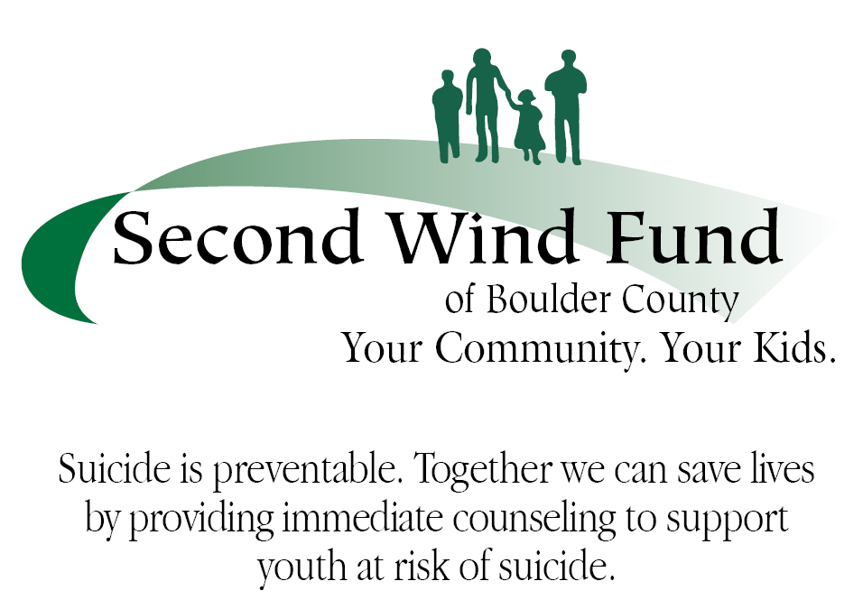
Second Wind Fund of Boulder County (SWFBC)
637-B South Broadway #118
Boulder, Colorado 80305
Swfbc.org@gmail.com
Swfbc.org, 720-212-7527

RELEASE OF INFORMATION AND WAIVER OF LIABILITY

I, , hereby authorize _________________________________________
(Boulder Valley School District, SVVSD and/or (agency name) or Counseling or referring person and the professional therapist that I shall choose, to release information to the SWF Boulder for purposes of evaluation of this program. I also authorize BVSD, SVVSD and agency personnel and its employees to release such information as they deem appropriate to the professional therapist. I understand that the purpose of this authorization is to disclose information that is relevant to my mental health treatment. I further understand that any treatment records concerning my mental health treatment may be confidential under Colorado law, and that statutory privilege may prohibit confidential treatment information from being disclosed without my consent. This release shall permit disclosure of information for a period of 60 days following completion or termination of treatment unless I have rescinded it earlier by providing written notice to SWF Boulder, BVSD, SVVSD, agency personnel or the therapist.

Client Signature Date

Parent Signature, Date 2nd Parent Signature, if required Date

WAIVER OF LIABILITY
I, , waive and release any claim that I may have
or that my child, may have against SWF of Boulder, its officers and directors, and BVSD, SVVSD, as well as its employees and agents, for any claim, injury or damages whatsoever asserted by parent or student in connection with referral of student for counseling services, disclosure of information between Second Wind, agency or school personnel and/or the private therapist, counseling services provided to student, or any other act or omission in connection with such services. This Waiver and Release is being made in exchange for the School District’s or agency referral of student to the therapist and for professional counseling services for which SWFBC will be paying. I understand that SWFBC is not providing services but funding them; and that no employee, agent, officer or director of SWFBC or agency or schools of BVSD or SVVSD will be providing services or treatment. I further understand that the treatment professionals to whom referrals may be made by SWFBC are independent professionals who are neither employees nor agents of SWFBC or BVSD, SVVSD, or other agencies.

This Waiver is made freely and voluntarily, and I acknowledge that I have read this Waiver and understand it.

____________________________________________
Parent 2nd Parent Signature, if required

Student Signature___________________________________________
*After this form is signed, please keep one signed version in your files or e-mail to swfbc.org@gmail.com, give one to client to give to therapist

